**LIFE SCIENCES P1 NOVEMBER 2019 NATIONAL SENIOR CERTIFICATE GRADE 12**

Correct answer in **BOLD**

Information in *ITALICS*

SECTION A

1.1.1 Which ONE of the following hormones controls metabolic rate?

A Testosterone *(produced by testes – male - stimulates the maturation of sperm cells and stimulates puberty in males)*

**B Thyroxin *(produced by thyroid gland – controls basic metabolic rate)***

C Growth hormone *(produced by pituitary gland - controls growth)*

D Insulin (*produced by Islets of Langerhans in the pancreas – stimulates conversion of glucose to glycogen which reduces blood glucose levels)*

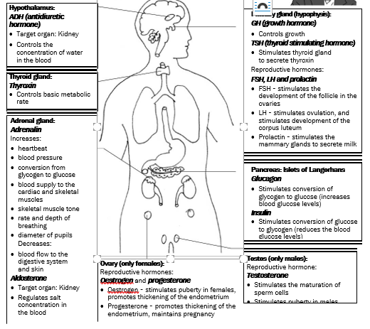

1.1.2 Which ONE of the following will occur in the human body on a cold day?

A Vasodilation in the skin *(on a hot day, blood vessels dilate – become wide – and more blood flows to the skin; more heat is lost from the skin and more blood is sent to the sweat glands)*

B Increase in the activity of sweat glands *(on a hot day more sweat is released and the evaporation of sweat cools the skin)*

**C Decrease in evaporation of sweat from the surface of the skin** *(and less cooling of the skin)*

D Increase in blood flow to the surface of the skin *(See A)*

IMPORTANT: Temperature regulation is the control of body temperature to keep it as close to 370C as possible to enable the body to function normally.

Body temperature is regulated by the hypothalamus in the brain and the blood vessels and sweat glands in the skin.

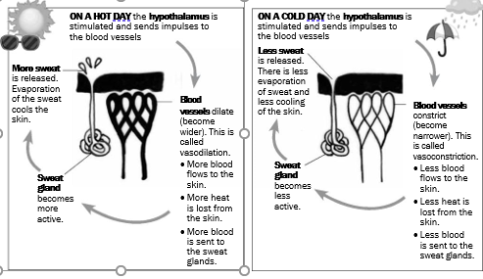

1.1.3 The list below includes some of the factors that affect food security:

(i) **Use of pesticides** *(**Can increase food security. Pest control involves the use of pesticides (chemicals) to kill pests that compete with humans for food. Many farmers now use biological control, which uses a natural predator/parasite to get rid of the pest instead of using expensive pesticides.)*

(ii) Soil erosion *(decreases food security. Caused e.g. by overgrazing and topsoil being washed away during rainstorms )*

(iii) **Genetic modification** *(Can increase food security. Genetically engineered food is produced from genetically modified organisms (GMOs). Genetic engineering involves the inserting of a gene (with a desired characteristic) from one organism into another organism to increase the yield. For example, a gene for drought resistance could be inserted into a crop plant that grows in areas where water is scarce.*

(iv) **Use of fertilisers** *(Can increase food security. The use of fertilizers, both inorganic (chemical) and organic (compost and manure) can increase the nutrients in the soil and keep soil fertile. This replaces nutrients in the soil that are lost when crop plants absorb them)*

Which ONE of the following combinations includes factors that **increase** food security?

A (ii), (iii) and (iv) only

B (i) and (iv) only

**C (i), (iii) and (iv) only**

D (i), (ii), (iii) and (iv)

**Food security**

Food security refers to the access, by all people at all times, to adequate, safe and nutritious food for a healthy and productive life. Food security may be influenced by the following factors:

**Exponential growth of the human population**

* The world's population is growing at an exponential rate (very rapidly) and as a result some countries cannot produce enough food to feed their growing population. Food production needs to increase as rapidly as the world population; otherwise many countries will experience food insecurity.

**Droughts and floods**

* Climate change has led to more frequent and severe droughts and floods. Droughts result in crop losses and livestock death which reduce the food available in an area. Floods cause extensive damage in a short period of time and decrease the amount of farmland available to grow crops. People also usually lose their homes, possessions and economic security during floods, further impacting on food security.

**Poor farming practices - monoculture, pest control, loss of topsoil and the need for fertilizers**

* **Monoculture** is the growing of one type of crop over large areas of land year after year. Monoculture depletes nutrients and water supplies and therefore impacts negatively on the quality of the topsoil.
* **Pest control** involves the use of pesticides (chemicals) to kill pests that compete with humans for food. Pesticides may kill or get into the tissues of healthy plants. This may reduce crop production and, since pesticides are expensive, increase the cost of food and thus reduce access to poor consumers. Many farmers now use biological control, which uses a natural predator/parasite to get rid of the pest instead of using expensive pesticides.
* **Topsoil** is the top 1.5 metres of soil that contain the nutrients that plants require for growth. The tilling of the soil between plantings and heavy rainfall cause much of the topsoil to be lost, leading to the loss of valuable nutrients over time, reducing crop yields.
* **The use of fertilizers**, both inorganic (chemical) and organic (compost and manure) can increase the nutrients in the soil and keep soil fertile. This replaces nutrients in the soil that are lost when crop plants absorb them. Fertilizers can be expensive, contributing to the high cost of food, thus reducing access to poor consumers.

**Alien plants and reduction of agricultural land**

* Alien plants deplete the topsoil of water and nutrients. These alien plants out-compete indigenous plants because they have no natural predators, grow rapidly and invade land that could be used to grow crops.

**The loss of wild varieties and the impact on gene pools**

* Crop plants have replaced wild varieties. The preservation of wild varieties is important because, if changing environmental conditions destroy the present crop plants, then wild varieties could be used as alternative sources of food. If wild varieties are wiped out, it will reduce the genetic diversity and thus the gene pool.

**Genetically engineered food**

* Genetically engineered food is produced from genetically modified organisms (GMOs). Genetic engineering involves the inserting of a gene (with a desired characteristic) from one organism into another organism to increase the yield. For example, a gene for drought resistance could be inserted into a crop plant that grows in areas where water is scarce.

**Food wastage**

* Wastage could occur during the storage, production and processing of food. Wastage includes food thrown away and food not eaten. Wastage increases the prices of food to consumers and could reduce food security in a country.

1.1.4 Which part of the neuron transmits impulses towards the cell body?

**A Dendrite (transmits impulses towards the cell body of the neuron)**

B Myelin sheath *(insulating layer around neurons (nerve cells) which allows electrical impulses to transmit quickly and efficiently)*

C Axon *(Transmits impulses away from the cell body of the neuron)*

D Synapse *(The synapse is the chemical junction between the axon terminals of one neuron and the dendrites of the next)*

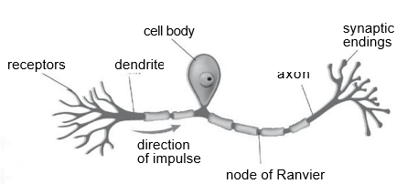

QUESTIONS 1.1.5 AND 1.1.6 ARE BASED ON THE DIAGRAM OF THE HUMAN MALE REPRODUCTIVE SYSTEM BELOW.

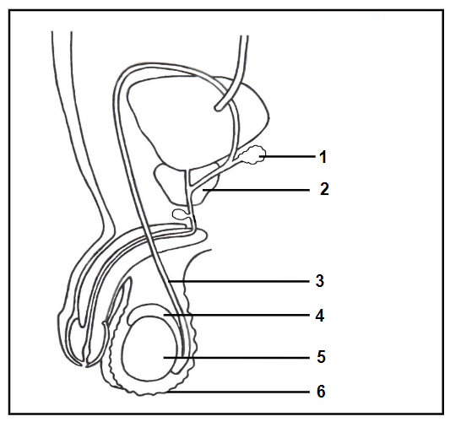

*1 Seminal vesicle: A gland that produces a nutrient rich fluid that that provides energy for the sperm cells*

*2 Prostate gland: Produces an alkaline fluid that neutralises the acids produced in the vagina, which would kill sperm cells*

*3 Vas Deferens (sperm duct): Transports sperm from the epididymis to the urethra*

*4 Epididymis: Sperm cells mature and are stored here*

*5 Testes: Produces sperm cells and the hormone testosterone*

*6 Scrotum: Skin sac that protects the testes and holds the testes ‘outside’ the body, at a temperature that is 2°C below 37°C. This is the best temperature for the production of sperm*

*Also: Cowper’s Gland: Produces mucus that helps with the movement of sperm cells*

*Urethra: Transports semen and urine out of the body*

1.1.5 Which part stores sperm until maturation?

A 3

**B 4** (Epididymis) See above

C 5

D 6

1.1.6 A man who had cancer underwent surgery to remove part 1 and part 2 (see above).

The man...

A will be able to release semen not containing sperm and therefore cannot reproduce.

B cannot reproduce because he will produce abnormal sperm.

**C cannot reproduce as his sperm will not be able to survive the acidic conditions of the vagina.**

D will be able to reproduce but his sperm will not be able to move fast as they will not have energy

1.1.7 Which ONE of the following shows the results when a cell with 20 chromosomes undergoes mitosis?

|  |  |
| --- | --- |
| **NUMBER OF DAUGHTER CELLS** | **NUMBER OF CHROMOSOMES** |
| **2** | **20** |
| 2 | 10 |
| 4 | 20 |
| 4 | 10 |

**Mitosis** is a process where a single cell divides into two identical daughter cells (cell division). During **mitosis** one cell divides once to form two genetically identical cells. The major purpose of **mitosis** is for growth and to replace worn out cells

1.1.8 Which ONE of the following is a function of amniotic fluid?

A Transports oxygen to the developing foetus *(Umbilical vein in the umbilical cord)*

**B Protects the foetus from temperature changes** *(and amniotic fluid protects the developing baby by cushioning against blows to the mother's abdomen, allowing for easier foetal movement and promoting muscular/skeletal development. Amniotic fluid swallowed by the foetus helps in the formation of the gastrointestinal tract.)*

C Produces progesterone and oestrogen *(mainly produced by the ovaries)*

D Protects the foetus from disease *(placenta by acting asa barrier to microbes and maternal antibodies pass from mother to child through the placenta)*

1.1.9 Which part of the ear contains the receptors for hearing?

**A Cochlea** *(contains the spiral organ of Corti, which is the receptor organ for hearing. It consists of tiny hair cells that translate the fluid vibration of sounds from its surrounding ducts into electrical impulses that are carried to the brain by sensory nerves.)*

B Tympanic membrane (also called eardrum, thin layer of tissue in the human ear that receives sound vibrations from the outer air and transmits them to the auditory ossicles, which are tiny bones in the tympanic (middle-ear) cavity.)

C Oval window (is a membrane-covered opening from the middle ear to the cochlea of the inner ear. Vibrations that contact the tympanic membrane travel through the three ossicles and into the inner ear.

D Round window *(is one of the two openings from the middle ear into the inner ear. It is sealed by the secondary tympanic membrane (round window membrane), which vibrates with opposite phase to vibrations entering the inner ear through the oval window.)*

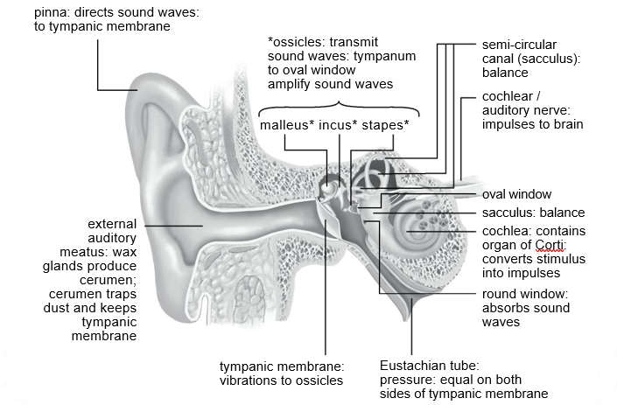

1.1.10 Which ONE of the following is a consequence of the round window of the ear hardens?

A Pressure waves will not be created *(due to damage of the oval window)*

B Impulses will not be transmitted to the brain *(due to damage of the auditory nerve)*

C Pressure between the outer and the middle ear will not be equalised *(blockage of eustachian tube)*

**D An echo will occur and the sound will be distorted.**

1.2 Give the correct **biological term** for each of the following descriptions. Write only the term next to the question numbers (1.2.1 to 1.2.9) in the ANSWER BOOK.

1.2.1 The finger-like projections that develop from the outer extra-embryonic membrane - **Chorionic villi**

1.2.2 Division of the cytoplasm during cell division - **Cytokinesis**

1.2.3 A plant species that does not belong to an area and which outcompetes the indigenous species of that area - **Invasive alien/Invasive exotic**

1.2.4 A structure in the female reproductive system where semen is deposited during copulation - **Vagina**

1.2.5 The permanent, large-scale removal of trees and vegetation from an area - **Deforestation**

1.2.6 A hormone that stimulates the mammary glands to produce milk - **Prolactin**

1.2.7 The period of development of the foetus in the uterus - **Gestation**

1.2.8 A structure in the female reproductive system where fertilisation takes place - **Fallopian tubes/Oviducts**

1.2.9 The stage when secondary sexual characteristics develop in males and females – **Puberty**

1.3 Indicate whether each of the descriptions in COLUMN I apply to **A ONLY**, **B ONLY**, **BOTH A AND B** or **NONE** of the items in COLUMN II. Write **A only**, **B only**, **both A and B** or **none** next to the question numbers (1.3.1 to 1.3.3) in the ANSWER BOOK.

|  |  |  |
| --- | --- | --- |
|  | **COLUMN I** | **COLUMN II** |
| 1.3.1 | The blood vessel that transports oxygenated blood from the placenta to the foetus | 1. **Umbilical vein** 2. Umbilical artery |
| 1.3.2 | A disorder caused by the degeneration  of the myelin sheath of motor neurons | 1. **Multiple sclerosis** 2. Alzheimer's disease |
| 1.3.3 | A measure of the total amount of carbon dioxide released by an individual per year | 1. Greenhouse effect 2. **Carbon footprint** |

1.4 The diagrams below represent the structures of an ovum and a sperm.

**Ovum Sperm**

|  |  |  |
| --- | --- | --- |
|  | **A**  **B** | **C D E F** |
|  |
|  |  |  |

1.4.1 Identify part:

1. **A Jelly layer/Zona pellucida**
2. **B Cytoplasm/cytosol**
3. **C Acrosome**

1.4.2 Name the process involving meiosis that leads to the formation of an ovum - **Oogenesis**

1.4.3 Write down only the LETTER of the part of the sperm that enters the ovum – **D** *(Acrosome)*

1.4.4 Write down only the LETTERS of TWO parts that enable the sperm to move towards the ovum – **E** *(mitochondria – provides energy for swimming*) and **F** *(tail)*

1.5 The diagram below shows some parts of the human central nervous system.

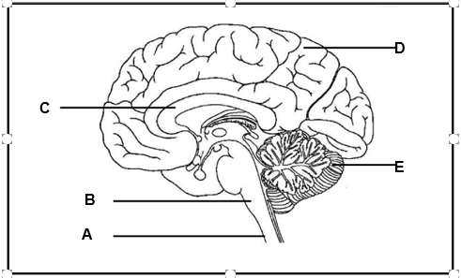

1.5.1 Identify part:

1. A **Spinal Cord** *(long, fragile tubelike structure that begins at the end of the brain stem and continues down almost to the bottom of the spine. The spinal cord consists of nerves that carry incoming and outgoing messages between the brain and the rest of the body.*
2. C **Corpus Callosum** *(Connects the left and right hemispheres of the brain - allowing communication between both hemispheres)*

1.5.2 Write down the LETTER and NAME of the part that:

1. Has the centre for interpreting taste – **D Cerebrum** (*Receives and interprets sensations from sense organs; Controls voluntary actions; Higher thought processes)*
2. Regulates the heart rate – B **Medulla oblongata** *(Transmits nerve impulses between the spinal cord and the brain; Controls involuntary actions such as heartbeat and breathing)*
3. Is responsible for motor coordination – **E Cerebellum** *(Coordinates all voluntary movements; Controls muscle tension to maintain balance)*



**SECTION B   
QUESTION 2**

2.1 The diagrams below represent different phases of meiosis in an organism.

2.1.1 Identify

(a) A **Centromere**

(b) B **Homologous Chromosomes**

(c) C **Spindle Fibre**

2.1.2 Identify the phase represented in DIAGRAM **3**. **Anaphase II**

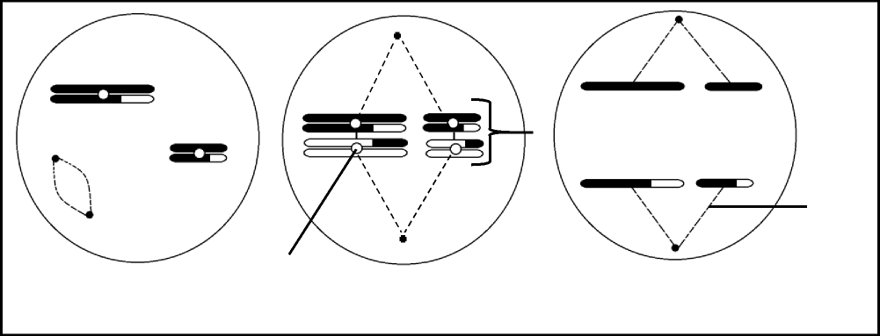

**Diagram 1 Diagram 2 Diagram 3**

**A**

**B**

**C**

2.1.3 Write down the numbers of the diagrams to show the sequence in which the phases occur.

**2 (Metaphase I), 1 (Prophase II) ,3 (Anaphase II)**

2.1.4 State ONE difference between metaphase **I** and metaphase **II**. **In metaphase I, the chromosomes arrange at the equator in homologous pairs whereas in metaphase II, the chromosomes arrange at the equator singly**

*Metaphase 1*

* The spindle extends across the whole cell.
* The homologous chromosomes line up along the equator of the spindle in their homologous pairs.
* One chromosome of each pair lies on either side of the equator.
* The centromere of each chromosome attaches to the spindle fibres.

*Metaphase 2*

Individual chromosomes line up at the equator of each cell, with the centromeres attached to the spindle fibres

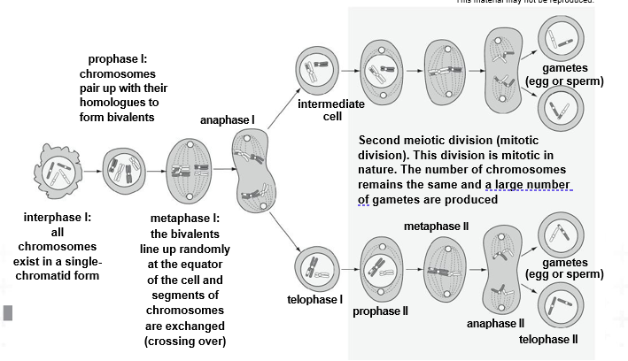

2.2 The table below shows a comparison of the composition of the amniotic egg in three different bird species.

|  |  |  |  |  |  |
| --- | --- | --- | --- | --- | --- |
| **COMPOSITION** | | **BIRD SPECIES** | | | |
| **1** | **2** | **3** | |
| Yolk (%) | | 17 | 36 | 22 | |
| Water content in yolk (%) | | 77 | 57 | 61 | |
| Energy (kcal/g) | | 1,04 | 1,44 | 1,14 | |
| 2.2.1 | | Define *ovovivipary*. **Eggs are retained/hatch in the female body and the young are born live**  live | | | | (2) | |
| 2.2.2 | | Which ONE of the bird species (**1**, **2** or **3**) most probably shows a | | | |  | |
|  | | precocial development reproductive strategy? **2 *(Hatchlings are quite well-developed when they hatch - eyes open, able to move, able to feed. Brain size and intelligence remains the same throughout their lives.)*** | | | |  | |
| 2.2.3 | | Explain your answer to QUESTION 2.2.2. **The egg has the highest yolk i.e. energy content that will allow maximum development before hatching** | | | |  | |
| 2.2.4 | | Which ONE of the bird species (**1**, **2** or **3**) will possibly produce | | | |  | |
|  | | offspring requiring the highest degree of parental care? ***(The egg has the lowest yolk i.e. energy content that will allow less development before hatching)*** | | | | (1) | |
|  | |  | | | | **(6)** | |

2.3 The table below indicates the percentage of visually impaired people in the world suffering from different visual defects.

|  |  |
| --- | --- |
| **VISUAL DEFECT** | **PEOPLE**  **(%)** |
| Blindness | 2 |
| Long-sightedness | 64 |
| Short-sightedness | 30 |
| Other | 4 |

2.3.1 Which visual defect in the table is the most common among the world population?

**Long-sightedness** *at 64%*

2.3.2 In some cases where people are blind, the condition is caused by cataracts.

1. Explain why people with cataracts may become blind. **The lens becomes opaque/milky/cloudy**

**and therefore does not allow the light to pass through**

1. State ONE way in which cataracts can be treated. **Surgery *(to replace the lens with a synthetic lens)***

2.3.3 Explain why long-sighted people need to wear glasses with biconvex lenses as a corrective measure. **The lens is less convex/the eye ball is too short/cornea is flat - This causes the light rays to fall behind the retina- A biconvex lens increases the refractive power - - Therefore light rays are focussed on the retina to form a clear image**

2.3.4 Name a visual defect that is characterised by an uneven cornea or lens. **Astigmatism**

2.3.5 Draw a pie chart to represent the data in the table.

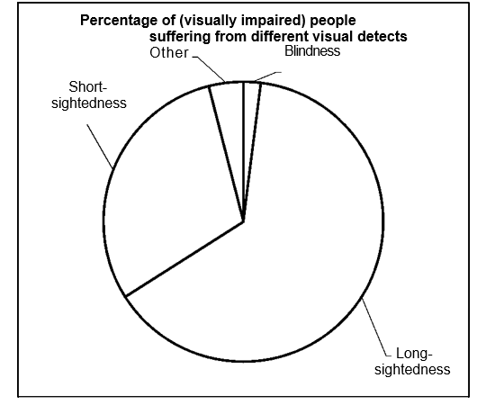

|  |  |  |
| --- | --- | --- |
| **Calculations:** |  |  |
| Blindness: | 2/100 x 360° = | 7,2° |
| Short-sightedness: | 30/100 x 360° | = 108° |
| Long-sightedness: | 64/100 x 360° | = 230,4° |
| Other: | 4/100 x 360° = | 14,4° |

2.4 Contraceptives are used to prevent pregnancy. Some females use pills that contain progesterone. In one packet there would be 28 pills, of which 21 contain different concentrations of progesterone according to the day in the cycle and the remaining 7 will contain no progesterone. A female has to take one pill daily at the same time in a given sequence, as shown below.

The graph below shows the difference in the progesterone levels during a menstrual cycle of a woman taking contraceptive pills and a woman not taking contraceptive pills.

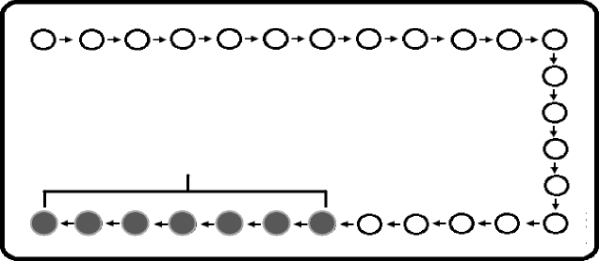

**Start here**

Mon Tue Wed Thur Fri Sat Sun Mon Tue Wed Thur

Sun Sat Fri Thu Wed Tue Mon Sun Sat Fri

Pills without progesterone

Thu

Fri Sat Sun Mon Tue Wed

2.4.1 The oestrogen levels between days **8** and **22** will remain low in the woman who takes contraceptive pills. Explain why this is the case. **The high levels of progesterone/in the pills will inhibit the secretion of FSH/from the pituitary gland. No follicle will develop and hence no oestrogen will be secreted**

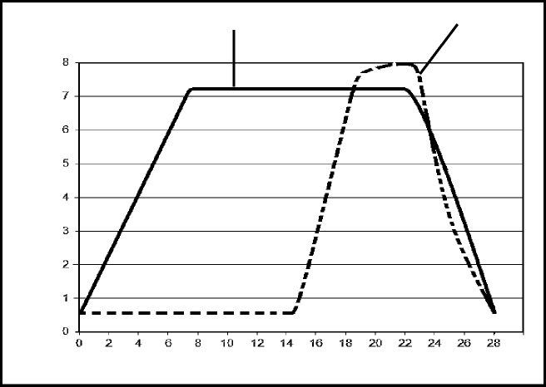

Progesterone (nanograms/mℓ)

With pills Without pills

Time (days)

2.4.2 Ovulation took place on day **14** in the woman not taking contraceptive pills. Explain the evidence in the

graph that supports this conclusion. **The increase in the progesterone level indicates that corpus luteum has been formed**

2.4.3 Suggest ONE reason for including pills with no hormones in the contraceptive pill packet. **Women will stay in the habit of taking a pill every day (will not forget to take the progesterone containing pills) OR To allow menstruation to occur)**

2.5 Describe the development of a zygote until implantation occurs.

**Zygote divides by mitosis to form a ball of cells called the morula which further divides to form a hollow ball of cells called the blastula/blastocyst**

**QUESTION 3**

3.1 The diagrams below show the re-absorption of salt and water through the tubules of a nephron in the kidney under three different conditions. The width of the arrows represents the amounts of salt and water.

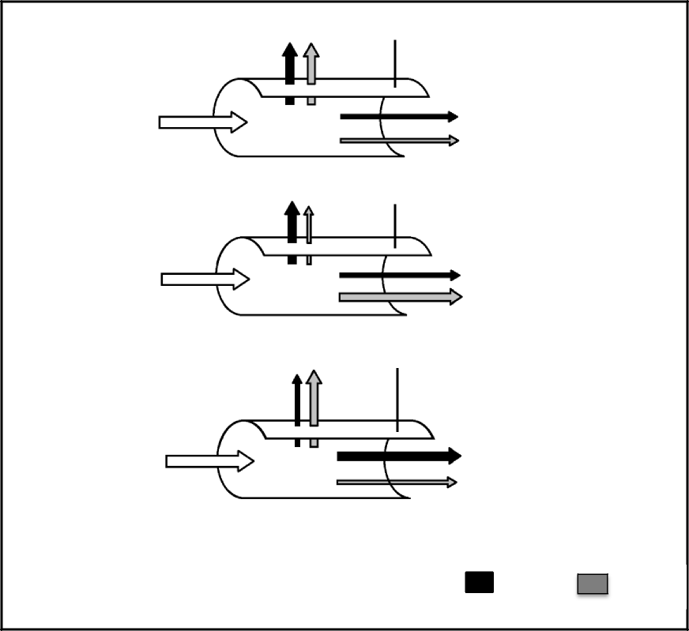

**Diagram 1**

Re-absorption

Renal tubule

Glomerular filtrate with salt and water

To the urinary bladder

Renal tubule

Re-absorption

**Diagram 2**

Glomerular filtrate with salt and water

To the urinary bladder

Renal tubule

Re-absorption

**Diagram 3**

Glomerular filtrate with salt and water

To the urinary bladder

KEY: r

Salt Water

3.1.1 Name the hormone in a human body that is responsible for

controlling the:

1. Water content **ADH/antidiuretic hormone/vasopressin**
2. Salt content **Aldosterone**

3.1.2 Name the gland that secretes the hormone in QUESTION 3.1.1(b). **Adrenal gland**

3.1.3 Which diagram (**1**, **2** or **3**) would represent a person who had eaten

salty chips on a hot day without any intake of water?  **3**

3.1.4 Explain your answer to QUESTION 3.1.3. **The blood will have a high salt content**

**- and therefore less/no aldosterone will be secreted - resulting in less salt reabsorbed into the blood more salt**

**excreted in the urine - The blood will have less water than normal - and therefore more ADH will be secreted**

**- making the kidney tubules more permeable - resulting in more water reabsorbed into the blood less water will leave the body with the urine**

3.2 Read the extract below.

People with Type I diabetes mellitus are usually insulin-dependent (must inject themselves with insulin to control their blood glucose levels). It has been determined that these people also lose their ability to secrete glucagon within five years of being diagnosed and they become glucagon deficient.

During a stressful situation adrenalin is secreted, which has the same effect as glucagon on the blood glucose levels.

An investigation was conducted to determine the influence of adrenalin on the blood glucose levels of Type I diabetics who were also glucagon deficient.

The investigation was conducted as follows:

* 100 male patients with Type I diabetes mellitus, who were also glucagon deficient, participated in the investigation.
* They were then given the same amount of food and water at the same time for a period of three days.
* Their blood glucose levels were measured on the morning of the third day.
* A solution with a low concentration of adrenalin was then administered intravenously (injected).
* After 20 minutes, the blood glucose concentration in each person was measured again.
* The blood glucose levels before and after administering adrenalin were compared.

|  |  |  |
| --- | --- | --- |
| 3.2.1 | Name the gland that secretes glucagon. **Pancreas (– Islets of Langerhans)** |  |
| 3.2.2 | Identify the independent variable in the investigation. **Adrenaline** |  |
| 3.2.3 | State THREE other factors that should have been kept constant |  |
|  | during the investigation.  **- Measuring tools used**  **- Person measuring the glucose concentrations**  **- Levels of activity - Age of patients**  **- Body mass of patients**  **- Health condition of patients** |  |
| 3.2.4 | Explain why the blood glucose levels were measured before |  |
|  | injecting adrenalin on the third day.  **Provides a baseline/starting level/point of reference/control and to compare with the effect of injecting adrenalin** |  |
| 3.2.5 | Explain why the adrenalin was injected instead of given orally.  injected into the patients.  **Hormones are proteins - and will therefore be digested/denatured making it ineffective**  **OR - Since it enters the blood directly - it will reach the target organs faster** |  |
| 3.2.6 | Explain what would be the expected results after adrenalin was |  |
|  | **The blood glucose levels will increase**  **- because an increase in adrenalin stimulates the conversion of**  **glycogen to glucose** |  |
| 3.2.7 | Give a reason for the use of 100 patients in the investigation |  |
|  | instead of only 10 patients. |  |
|  | **Increases reliability of the results** |  |

3.3 The diagram below shows a dam that was built in a flowing river.

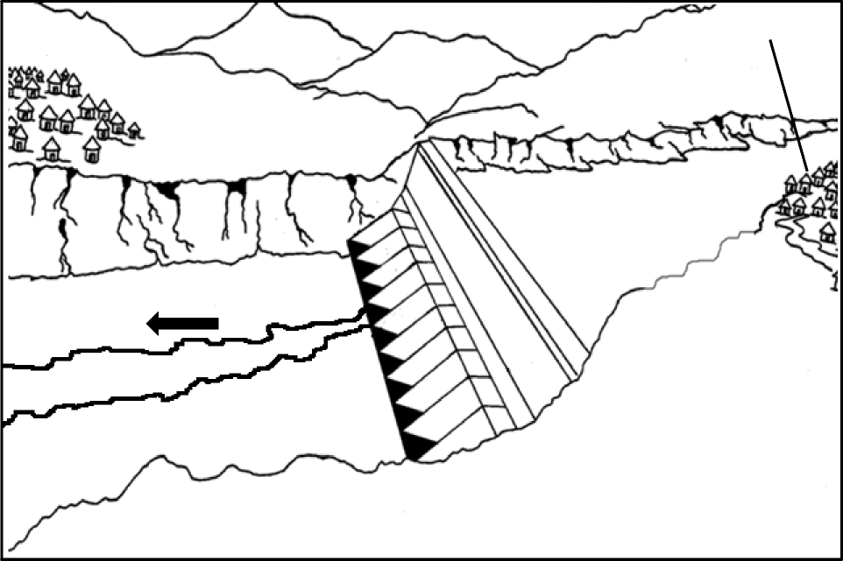

Village 1 Village 2

Direction of flow of river

River

Dam wall

Dam water

3.3.1 Explain how the presence of a dam can affect the biodiversity in the river.

**The flow of the river decreases/size of habitat decreases**

**- This may affect migration patterns/spawning of fish**

**- Opening of floodgates increases pressure of water flow**

3.3.2 Village **2** is a farming village that uses fertilisers to increase their crop yield.

Describe the impact of fertilisers on the quality of water when they are washed into the dam during heavy rains.

**The water quality will decrease\***

**- as the fertilisers increase the amount of nutrients/cause eutrophication**

**- which will result in algal bloom**

**- This will block-out the sunlight**

**- The under-water plants cannot photosynthesise/die**

**- Animals that feed on plants also die**

**- This leads to an increase in decomposers feeding off the dead organisms**

**- The decomposers deplete the oxygen in the water**

3.3.3 Explain ONE economic benefit of the constructed dam to the people living in Village **2**.

**Constant availability of water to increase crop yield**

**- More food will be available and hence less money spent on buying agricultural products**

**- More people are employed in the management of agriculture/dam/tourism therefore more income stability for the people in the community**

3.4 The diagram below shows the total amount of plastic produced between 1950 and 2015 and what happened to it.

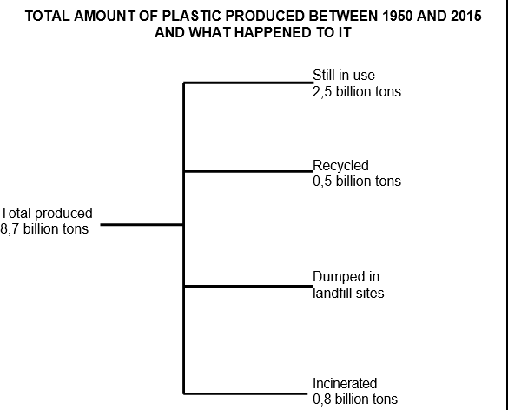

3.4.1 Calculate how much plastic (in billions of tons) produced between 1950 and 2015 ended up in landfill sites. Show ALL calculations.

**8,7 – 3,8/ OR 8,7 - (2,5 + 0,5 + 0,8)**

**= 4,9 / billion tons**

3.4.2 Describe the impact of incinerating (burning) plastic on global warming.

**There would be an increase in global warming/\***

**- The burning of plastic releases carbon dioxide/into the**

**atmosphere**

**- leading to the enhanced greenhouse effect/**

**- increasing the amount of heat trapped in the atmosphere/ - causing an increase in temperature**

3.4.3 Explain TWO strategies that municipalities could implement to increase the amount of plastic that is recycled by a community.

**Supply special bins//garbage bags to encourage the collection**

**of plastic/**

**- Bring recycling stations close to communities/to increase**

**access/**

**- Increase campaigns// awareness/ education on the benefits of recycling/**

**- Giving incentives/ for collecting more plastics/**

**SECTION C**

**QUESTION 4**

Both plants and humans respond to gravity.

Explain why the root and the stem grow in different directions when a pot plant is placed horizontally on the ground, receiving light equally from all directions.

Also describe the role of the maculae in maintaining balance when a person tilts his/her head to one side without falling over.

**When a plant is placed horizontally:   
- auxins are attracted by gravity/**

**Root**

**- There is a high concentration of auxins on the lower side of the root/**

**- which inhibits growth/cell elongation/cell division on the lower side/**

**- There is a low concentration of auxins on the upper side of the root/**

**- which stimulates growth/cell elongation/cell division on the upper side/**

**- The upper side of the root grows faster//Uneven growth occurs**

**- causing the root to grow/bend downwards/**

**- The root grows towards gravity//The root is positively geotropic**

**Stem**

**- There is a high concentration of auxins on the lower side of the stem/**

**- which stimulates growth/cell elongation/cell division on the lower side/**

**- There is a low concentration of auxins on the upper side of the stem/**

**- which inhibits growth/cell elongation/cell division on the upper side/**

**- The lower side of the stem grows faster//Uneven growth occurs   
- causing the stem to grow/bend upwards/**

**- The stem grows away from gravity//The stem is negatively geotropic (11)**

**Maintaining balance (B)**

**When the position of the head changes, the maculae:**

**- are stimulated/**

**- The stimulus is converted to an impulse/-which is transmitted by the auditory nerve/**

**- to the cerebellum/ - where the impulse is interpreted/ - The cerebellum sends impulses to the muscles/ - and balance is restored/**